PRESS RELEASE
PRESSURE BOUNDARY TOOLS
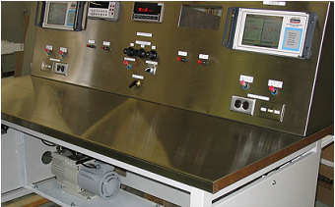
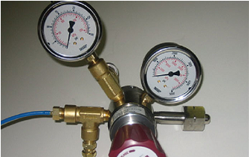

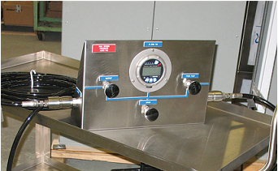
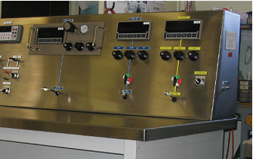
RE: PRESSURE BOUNDARY TOOLS

TECHNEL Engineering designs custom Pressure Boundary Tools to meet the specific requirements of your application then manufacture, test and provide on-site training. Since Technel Engineering Inc. has TSSA Certificates of Authorization QA 02458 and QA02459, all customized tools can come with a CRN (Canadian Registration Number) and if required an ESA (Electrical Safety Authority) or CSA (Canadian Standards Association) inspection and certificate.

Pressure Boundary Tools is a generic name for any device or system that includes a changing of pressure across a component such as a pressure regulator. Different examples of pressure boundary tools are shown in the photograph.

Upper left photo is a P10 (90% Argon, 10% Methane) Pressure Regulator used to reduce pressure from a standard 2200 psi cylinder to a range of 1 to 14 psi. The regulator is part of a beta radiation hand scanner system where the gas is used as a vehicle to sense the radiation. The actual regulator consists of 2 gauges, pressure relief valve, purge valve and 1 m of special polyethylene tubing.

Upper right photo is a low pressure/vacuum calibration bench with 5 work stations. Note the vacuum pump in the lower left side of the panel. Pressure calibration is via two, dual channel, touch screen Mensor APC600 Automatic pressure Controllers. The operator has available 12 pressure ranges from 2.5 psig to 500 psig. Included in the panel is access to 120V AC, 40 V DC, 48 V DC and an Agilent 34401A Meter.

Bottom right photo is a cart mounted 3,000 psi hydraulic hand pump. (pump not visible, mounted on lower shelf) The pump will handle a variety of fluids including water. Application is to provide an accurate source of high pressure liquid in the field for testing small volume systems. System consists of a Crystal digital meter, valving for inlet, outlet and drain and a 30 ft test hose. The hose is connected via a Quick Connect and the test end has a check valve, purge valve and Quick Connect. Various adapters are supplied loose in a cart mounted box to handle most field fittings.

Bottom left photo is a partial view of a 10 ft pressure / vacuum calibration bench with 7 work stations. The panel is all pneumatic and provides pressure from 5,000 psi to 1 milliTorr of vacuum. There is a built-in pressure intensifier and a vacuum pump. Pressure calibrators are the Condec DLR3110 Series. The operator also has available 120 V AC, a removable Agilent 34401A , 45 V DC and Test Jacks to measure current flow thro the 45 V DC.

Complete technical information is available from Technel Engineering Inc., Woodbridge, Ontario, phone: 1-888-882-1172, fax: 905-851-5743 or E-mail: info@technel.com

