Enhanced Oil Recovery Research using Quartz transducers

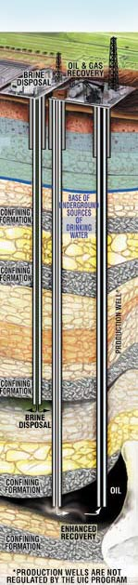
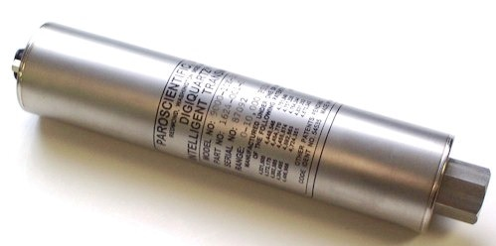
Figure 1
With greater emphasis on reducing reliance on oil imports, research is being focused on enhancing the recovery rates of proven domestic sources of oil.
Conventional methods can only recover 20 to 40% of a particular oil reservoir’s total capacity; advanced methods can increase this fraction to 30 or even 60%, sometimes doubling the potential life and output of a well. The problem is, each reservoir is unique and responds to each technique in a different way.

The properties and contents of an individual reservoir need studied to determine the best method for enhancing the oil recovery from that reservoir. Precise pressure readings are required throughout this process and the transducer of choice for this kind of research is the Paroscientific model 9000.

Unlike piezoresistive technologies, Paroscientific piezoresonant transducers exhibit very little drift over time and do not require periodic re-zeroing, even when exposed to the high temperatures typically involved in geologic research. This reduces potential experimental error related to sensor drift during long term testing or potential human error during re-zeroing.

Achievable sensor resolution in the range of parts per billion of range allows researchers to continuously monitor and control pressures in their research systems to closely match real-world conditions. This also allows fine monitoring of experimental conditions and subtle changes in the system.
Paroscientific transmitters have the advantage of being among the world’s most accurate digital pressure sensing technologies, at 0.01% of range. This again reduces cumulative experimental error.

Paroscientific pressure transducers are already being used in a wide variety of applications across Canada, from Barometric monitoring at airports and environmental stations, to high- and low-temperature and pressure applications, to water level monitoring and tsunami detection.

For more information on Paroscientific piezoresonant pressure transducers, please contact Technel Engineering Inc, 1-888-882-1172, www.technel.com

US Department of Energy, http://www.fossil.energy.gov/programs/oilgas/eor/index.html retrieved 2013-02-15
Paroscientific 19-year Barometer Stability test http://www.paroscientific.com/pdf/G8806-001_WEB.pdf Figure 1, US Environmental Protection Agency http://water.epa.gov/type/groundwater/uic/wells_drawings.cfm Retrieved Feb. 2013

