PRESS RELEASE
CUSTOM CALIBRATION BENCHES
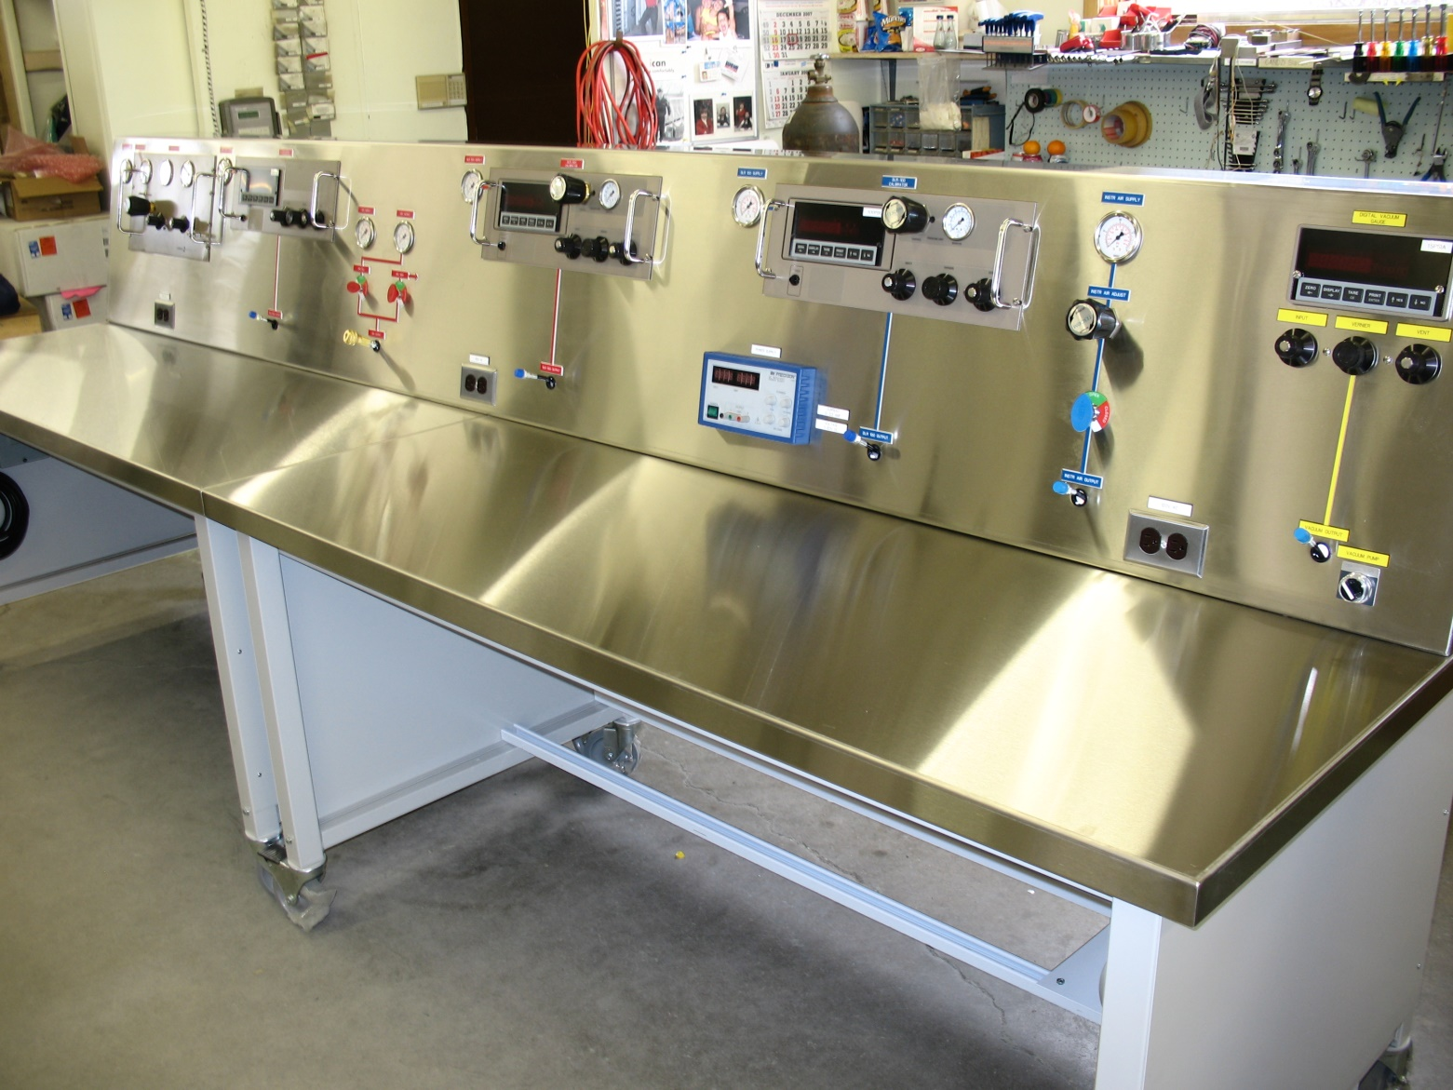
RE: CUSTOM CALIBRATION BENCHES

TECHNEL Engineering designs, manufactures, supervises installation and provides on-site training for custom calibration benches.

Benches are designed to meet your specific application and can incorporate pressure & electrical calibrators.

Technel Engineering Inc. has TSSA Certificates of Authorization QA 02458 and QA02459 which allows Technel to provide CRN’s for the benches.

We have deigned and manufactured a variety of custom systems from a cart mounted 3000 psi Hand Pump to Pressure Calibration Benches ranging in length from 5 feet to 12 feet.

Pressure calibration benches have been provided which include 7 test stations that provide accurate, stable sources of pneumatic pressure from 5,000 psi to full vacuum.

All customized benches come with an ESA (Electrical Safety Authority) or CSA (Canadian Standards Association) inspection and certificate. Complete technical information is available from Technel Engineering Inc., Woodbridge, Ontario, phone: 1-888-882-1172, fax: 905-851-5743 or E-mail: info@technel.com

